South China University of Technology
《Operation System》Experiment Report
Experiment Title： Session 3
Name： 陈宇勋 Student ID： 202230430026
Class： 22计科全英创新班 Group： None
Collaborator： None
Teacher： 钟竞辉
Description
【Objective and Requirement】
Implement a myfind command using system calls (e.g., opendir, readdir, and stat). The myfind command starts from the specified directory and recursively looks up the specified file. The command format is as follows：
myfind PATH -option parameters
PATH：The directory for looking up.
-option parameters：
-name “file”： Specify the name of the file to be found, support fuzzy search using wildcard characters e.g., ? *;
-mtime n：Search by time, search for files modified n days before today.
Finally, output the search results to standard output.
【Environment】
Operating System：Linux;
Content
【Procedure】
1. Step：In task, I create a python file to satisfy the requirement. In these python files, I use modules “os”, “fnmatch”, “time”, “argparse” to realize the function.
①In my python file, function “match_mtime(filepath, days)” will deal with the time matching requirement, if the parameter “mtime” is set.
②In my python file, function “search_dir(path, name_pattern=None, mtime_days=None)” will search the specific directory and its subdirectory. If there is a file which match the pattern, then the file path with be printed, and then continue to search, until all the directory has been searched.
Then I run each file in Ubuntu24.04, and obtain the following results.
2. Results：
① Without any option parameters:
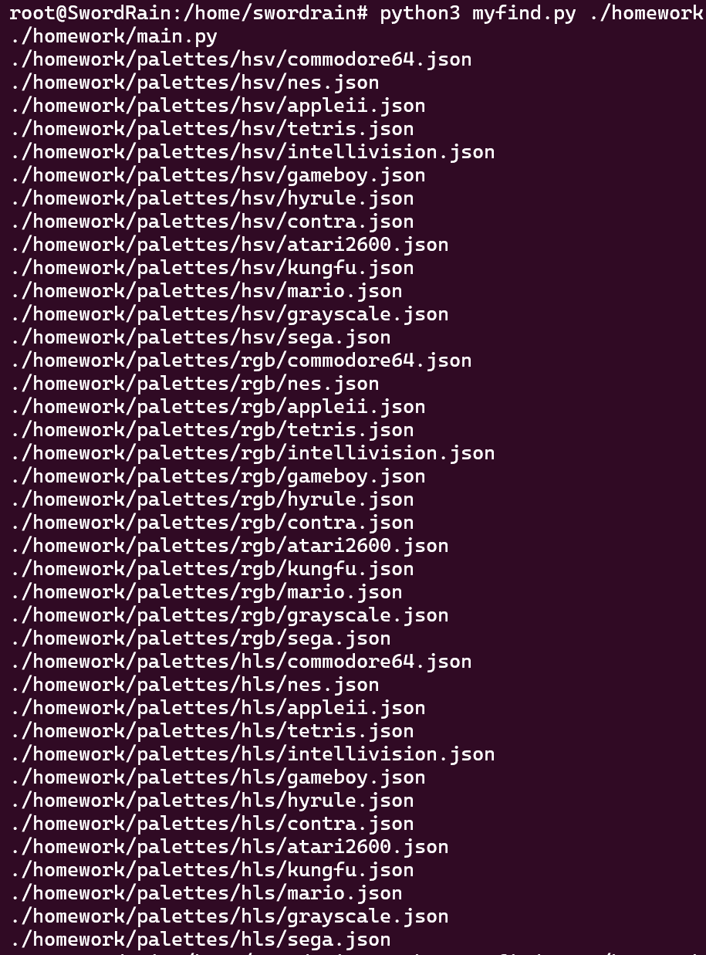
② With option parameters name and mtime
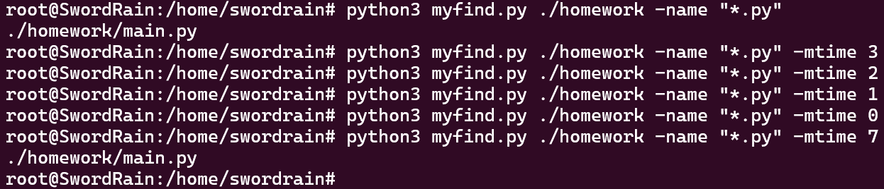
③ With option parameters name
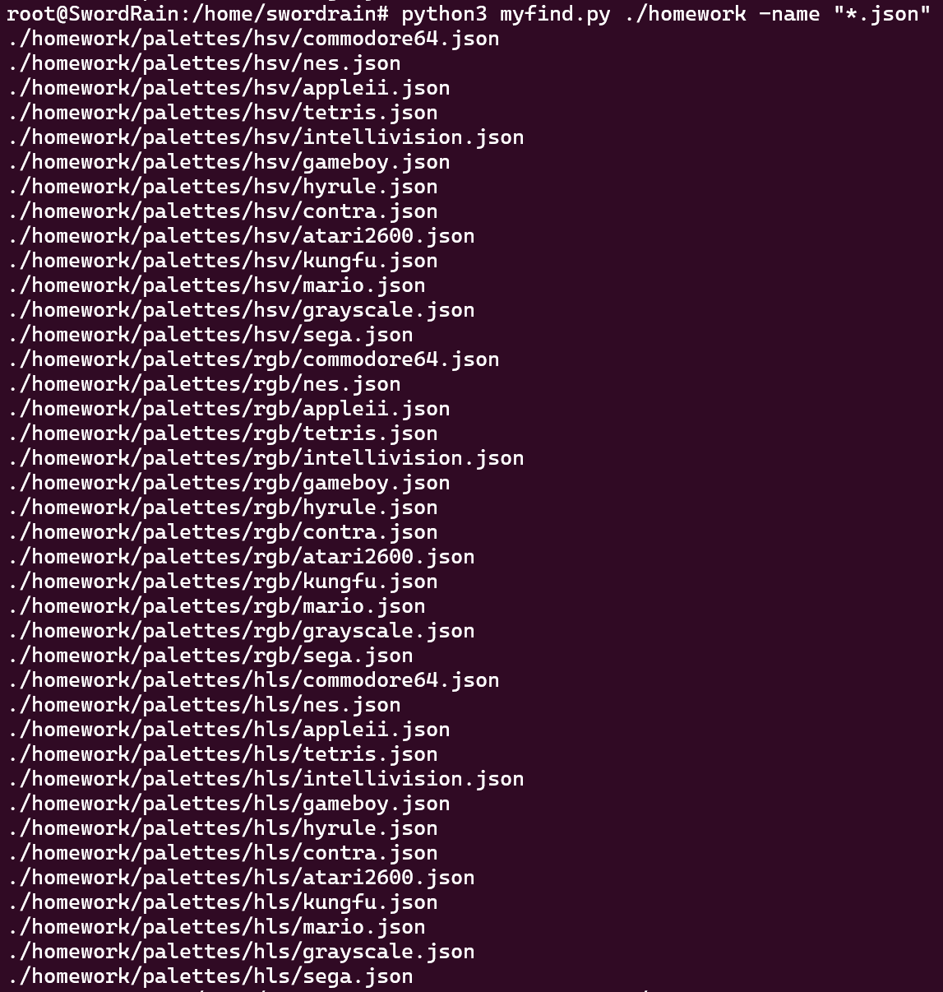
Conclusion
In this experiment, I have learned how to realize a simple “find” command in Linux, which is a simple but important command.
Teacher’s Comments and Score
Comment：

Score： Signature：
Date：
Appendix: Python Code
myfind.py
import os
import fnmatch
import time
import argparse

# 检查文件是否符合修改时间条件
def match_mtime(filepath, days):
try:
file_mtime = os.path.getmtime(filepath)
current_time = time.time()
file_days = (current_time - file_mtime) // (60 * 60 * 24)
return file_days == days
except Exception as e:
print(f"无法获取文件修改时间: {filepath}, 错误: {e}")
return False

# 递归搜索目录
def search_dir(path, name_pattern=None, mtime_days=None):
try:
for root, dirs, files in os.walk(path):
for filename in files:
filepath = os.path.join(root, filename)
if name_pattern and not fnmatch.fnmatch(filename, name_pattern):
continue
if mtime_days is not None and not match_mtime(filepath, mtime_days):
continue
print(filepath)
except Exception as e:
print(f"无法访问目录: {path}, 错误: {e}")

def main():
parser = argparse.ArgumentParser()
parser.add_argument("path")
parser.add_argument("-name")
parser.add_argument("-mtime", type=int)
args = parser.parse_args()
search_dir(args.path, name_pattern=args.name, mtime_days=args.mtime)

if __name__ == "__main__":
main()

